**Step 1.**

Right click on project name in solution explorer.

Add.

New Scaffolded Item…

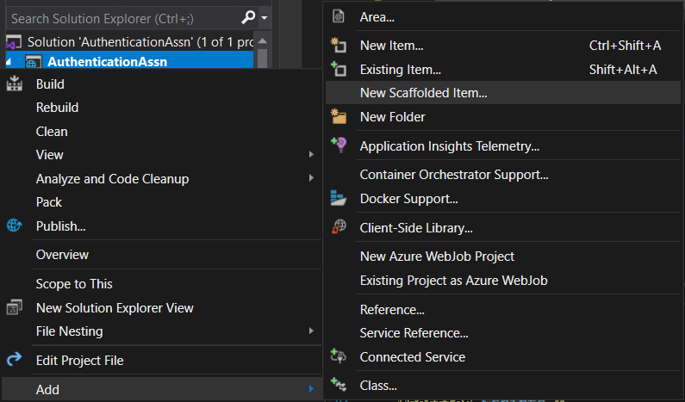

**Step 2.**

Go to Identity under Common in the left-hand side menu.

Click Identity.

Click Add.

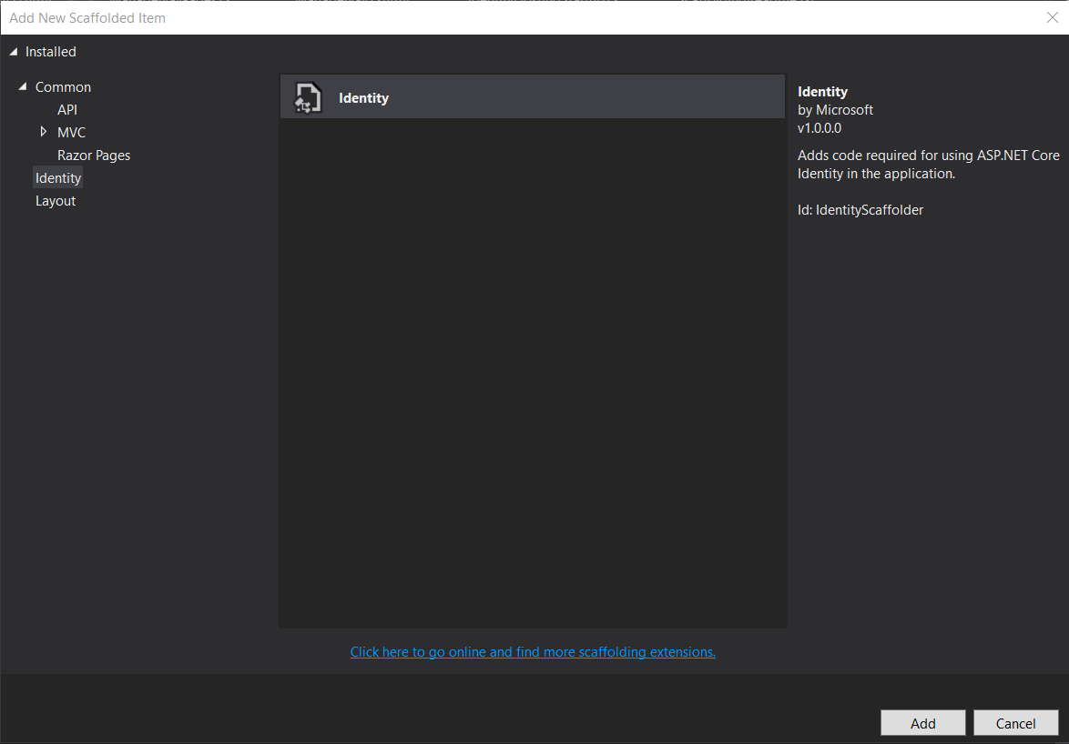

Allow VS to load.

**Step 3.**

Click Override all files or click all boxes if you’re a masochist.

Then the drop-down box next to Data context Class apply ApplicationDbContext.

Then add.

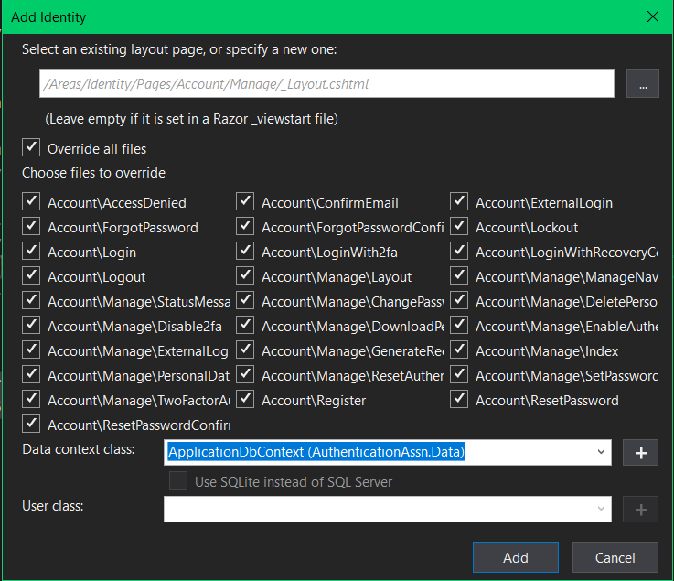

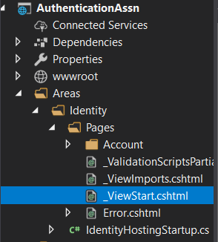**Step 4.**

Now under Areas/identity/pages in the solution explorer.

Open _ViewStart and change Layout’s value to “/Views/Shared/_Layout.cshtml”.

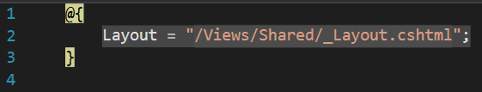

(Sometimes it is already correct you won’t need to change it in that case)

Next open the Account/Manage folder in the solution explorer.

And open _Layout.cshtml.

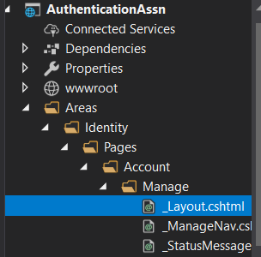

And do the same changing Layout’s value to “/Views/Shared/_Layout.cshtml”.

